Email Harvesting With theHarvester (osint tool)

What is theHarvester?
- A reconnaissance tool for gathering emails, subdomains, IPs, and more.
- Useful in OSINT (Open Source Intelligence) and ethical hacking.

🛠️ What it does:
- Searches public sources like:
  - Google, Bing, Yahoo
  - LinkedIn, Twitter
  - Shodan, DNSdumpster
- Collects:
  - Emails
  - Subdomains
  - Hostnames
  - Open ports (if using Shodan)(active recon)

theHarvester -h

it has both the ability of passive and active recon.
The sodan flag in it is important.
-s

You can also search by the company name but it does not give the exact company information as a lot of info are present.
theHarvester -d INE -b bing,duckduckgo,urlscan
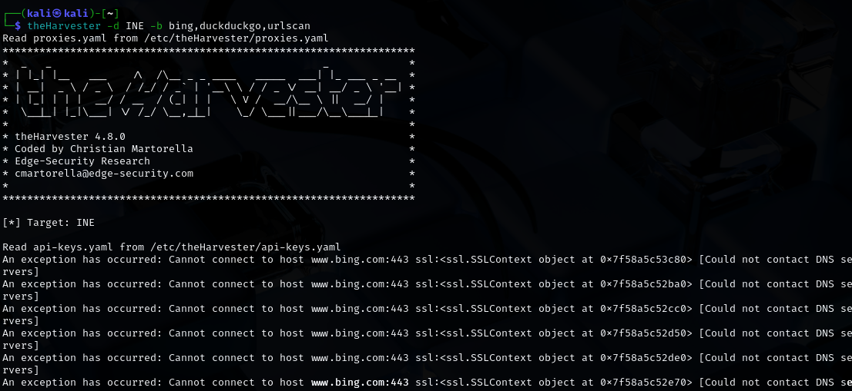

theHarvester -d ine.com -b duckduckgo,dnsdumpster,censys,urlscan
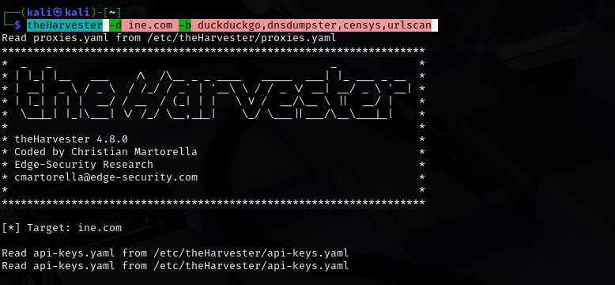

theHarvester -d zonetransfer.me -b duckduckgo,urlscan,tomba,bing,intelx,subdomaincenter

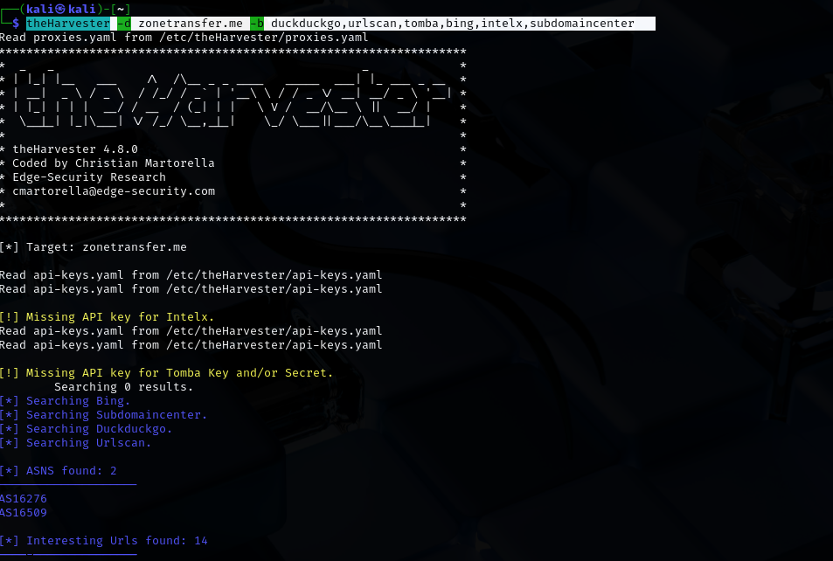
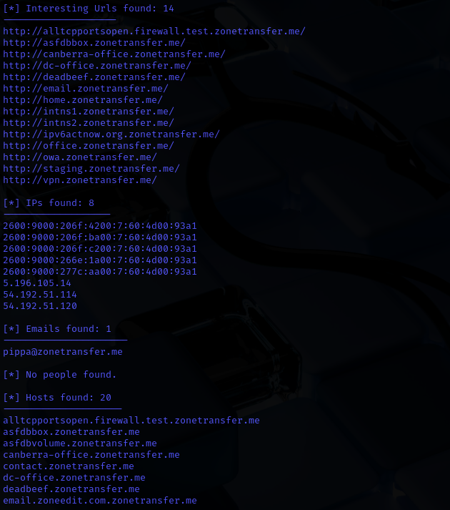

To check that your email is been pawned or not:
https://haveibeenpwned.com/

